AI ASSISTED CODING

ASSIGNMENT-11.2

Task Description #1 – Stack Implementation

Task: Use AI to generate a Stack class with push, pop, peek, and is_empty  
methods.  
Sample Input Code:  
class Stack:  
pass

Expected Output:  
• A functional stack implementation with all required methods and  
docstrings

PROMPT: generate a Stack class with push, pop, peek, and is_empty methods. Sample Input Code: class Stack: pass

CODE: 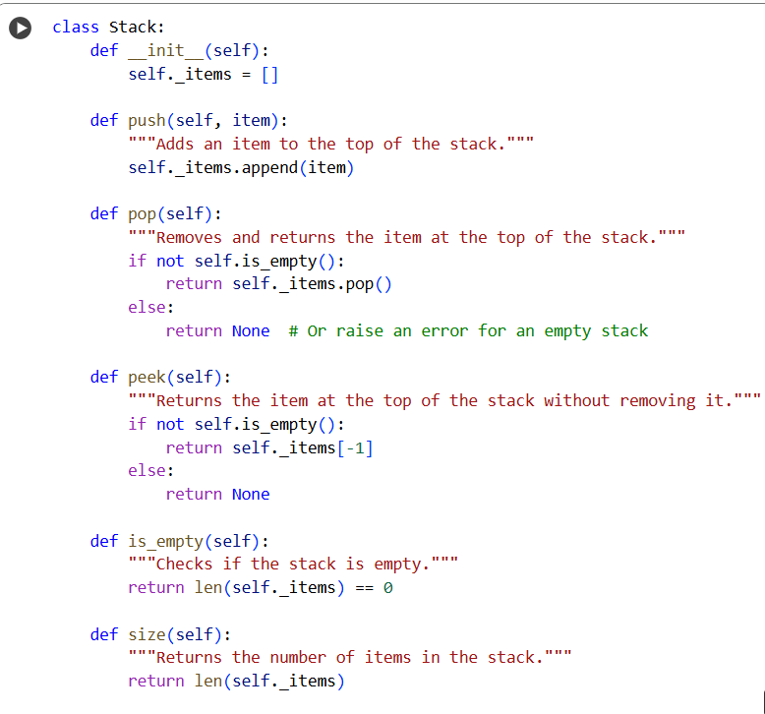

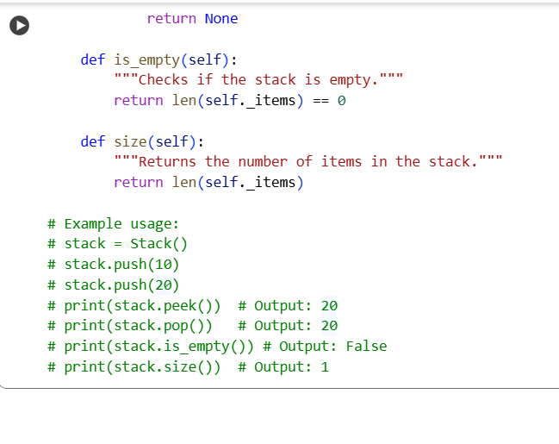

Task Description #2 – Queue Implementation

Task: Use AI to implement a Queue using Python lists.  
Sample Input Code:  
class Queue:  
pass

Expected Output:  
• FIFO-based queue class with enqueue, dequeue, peek, and size  
methods

PROMPT: generate a Stack class with push, pop, peek, and is_empty methods. Sample Input Code: class Stack: pass

CODE:

